**AMDM**

**Course Syllabus 2025-2026**

**Email address:** [**jenkimi@boe.richmond.k12.ga.us**](mailto:jenkimi@boe.richmond.k12.ga.us)

[**Chenjo@boe.richmond.k12.ga.us**](mailto:Chenjo@boe.richmond.k12.ga.us)

**Phone Number: (706)-592-2089**

**Please join Band app: TBA**

**Course Description and Objectives**

Advanced Mathematical Decision Making (AMDM) (27.08500) is a fourth-year   
mathematics course option designed to follow the completion of Advanced Algebra:   
Concepts and Connections. Students will enhance their understanding of concepts explored   
in the context of real-life phenomena. The intent of this course is for students to combine   
their understanding of multiple mathematical concepts as they explore and solve real-world   
mathematical problems. Students will investigate applications of mathematics in a variety of   
contexts, including business and financial decision-making, earning, investing, spending,   
and borrowing money, using functions to model problem situations in both discrete and   
continuous relationships, and using ratios, rates, and percentages to solve problems,   
  
Instruction and assessment should include the appropriate use of manipulatives and   
technology. Topics should be represented in multiple ways, such as concrete/pictorial,   
verbal/written, numeric/data-based, graphical, and symbolic. Concepts should be introduced   
and applied, where appropriate, in the context of realistic phenomena.

**Assignments and Absences**

Students will receive a variety of assignments designed to enhance their learning. If a student is absent, the student is responsible for the missed assignment. Students who have an absence will have 5 days to turn in missing assignments any days after the 5 days is teacher discretion.

Course Assessment Plan/Grading Scale: 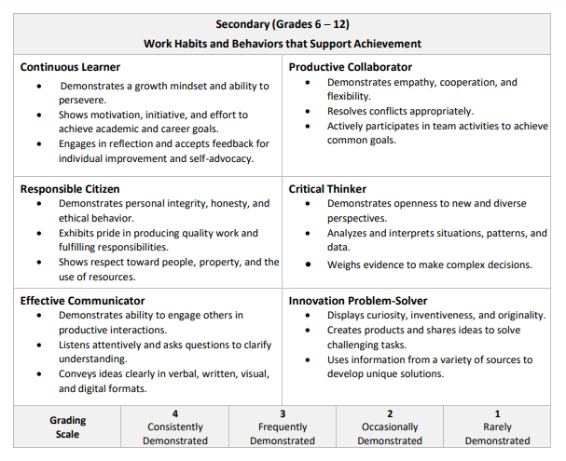

Major Assignments 40%

Minor Assignments 60%

**Grade recovery consists of assignments created by the teacher.**

**School Expectations**

Follow all school rules and policies (REBEL Alert – PBIS).

- P-Principled

- R-Reflective

-I-Innovated

-D- Disciplined

-E- Excellent

**Course Material**

* **1 Large** Three-ring binder (” or 2”) or Composition notebook
* Pencils
* 1 Package of Dividers (Label: Notes, vocabulary, etc...)
* Erasers
* Loose Leaf Paper
* Personal Computer or school issue computer (see media specialist for school issue computer)

**Classroom Procedures and Expectations**

1. Walk into the classroom quietly and take your seat.
2. If you are tardy, you must have a pass from either the office or teacher that kept you late.
3. As soon as you are seated, get out all materials needed for class.
4. During assessments you are to raise your hand if you have a question, and I will come to you. Always bring a book to read after you finish your test as not everyone will finish the test at the same time.
5. During class work, raise your hand and I will recognize you
6. If you are absent, it is your responsibility to check with your teacher and check canvas to see which assignments you missed.
7. Do not stand up, pack your book bag, clear off your desk or leave the classroom until instructed to do so.
8. During a fire or tornado drill, remain calm and walk quietly to our designated areas.
9. During any announcements be quiet and listen until they are finished.

**Classroom Rules**

1) Be respectful

2) Sit in assigned seat

3) **No food or drink**

**4) Keep electronics put away**

**Classroom Consequences**

1) verbal warning

2) parent contact

3) administration involvement

All consequences will be aligned with the HHS school wide discipline plan.

**Conferences**

**In order to schedule a conference with your teachers, please contact the Guidance Office 706-592-2089**

**Tutoring: TBA**

**Signature Page**

By signing below, we acknowledge that we have read and understand the

Course Syllabus 2025-2026 AMDM

Student Signature ___________________________________ Date ____________________

Parent Signature ____________________________________

Parent contact information :

Home phone number : __________________________________________________

Cellphone number : _____________________________________________________

Work number : ___________________________________________________________